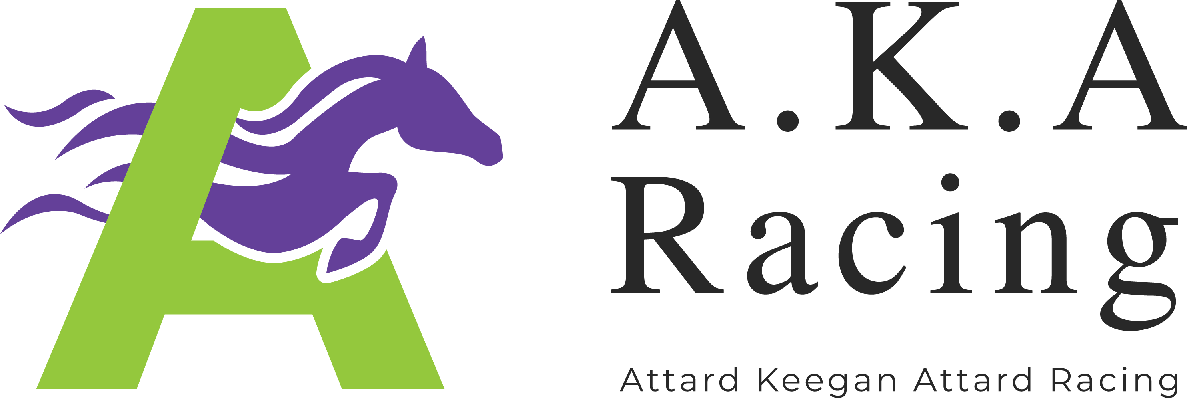

“I, Jason Attard & Lucy Keegan-Attard of The AKA Racing Partnership Pty Ltd hereby agree to train the following horse:

Bay 2019 Filly by Better Than Ready from Majeed

This filly will be trained by us from our stables at Grose Vale / Hawkesbury in accordance with my standard terms of trade at a base rate of $110.00 including GST.

I also give permission for Vardy Thoroughbreds Syndications to list myself as trainer in any advertisement in relation to this filly and confirm that I have no previous association or financial interest in this horse.

I offer this letter for inclusion in a Product Disclosure Statement promoted by Vardy Thoroughbreds Syndications.

My Fees Notice is attached.”

…………………………………………..
Jason Attard & Lucy Keegan-Attard

